**Insight by Problem, Sub-Problem, Issue, and Sub-Issue**

We can look at the most common products, sub-products, issues, and sub-issues within the consumer complaint data:

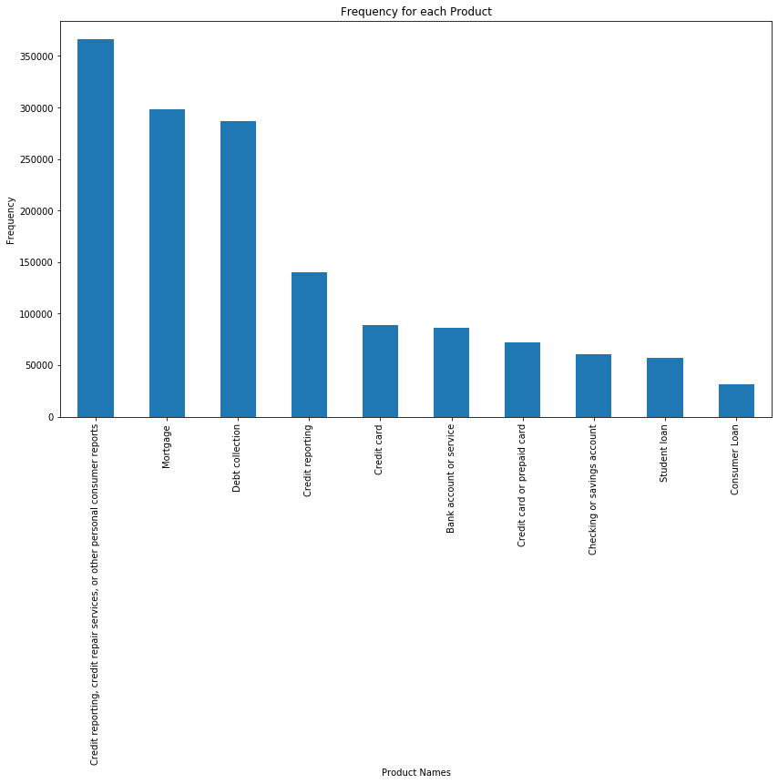

Products

1. Credit Reporting
2. Mortgage
3. Debt Collection

Sub-Problems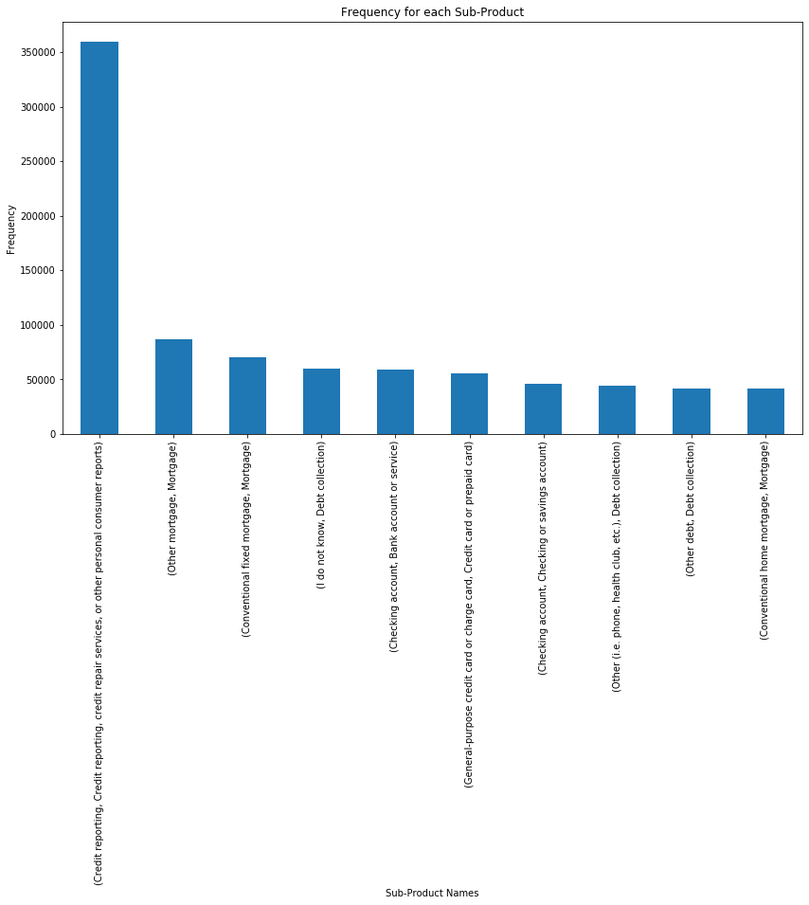

1. Credit Reporting
2. “Other Mortgage”
3. Conventional fixed mortgage

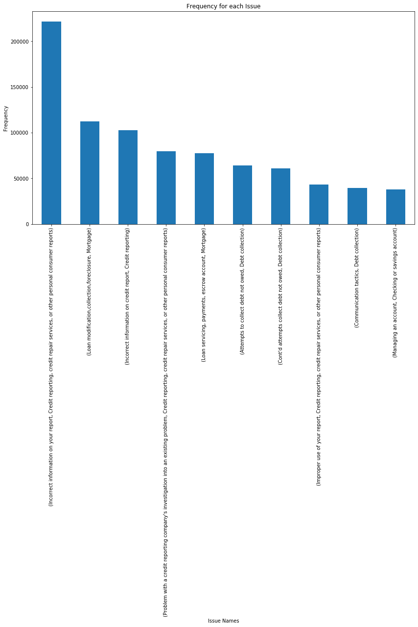

Issues:

1. Incorrect information your credit report
2. Loan modification (mortgage)
3. Problem with credit reporting company’s investigation

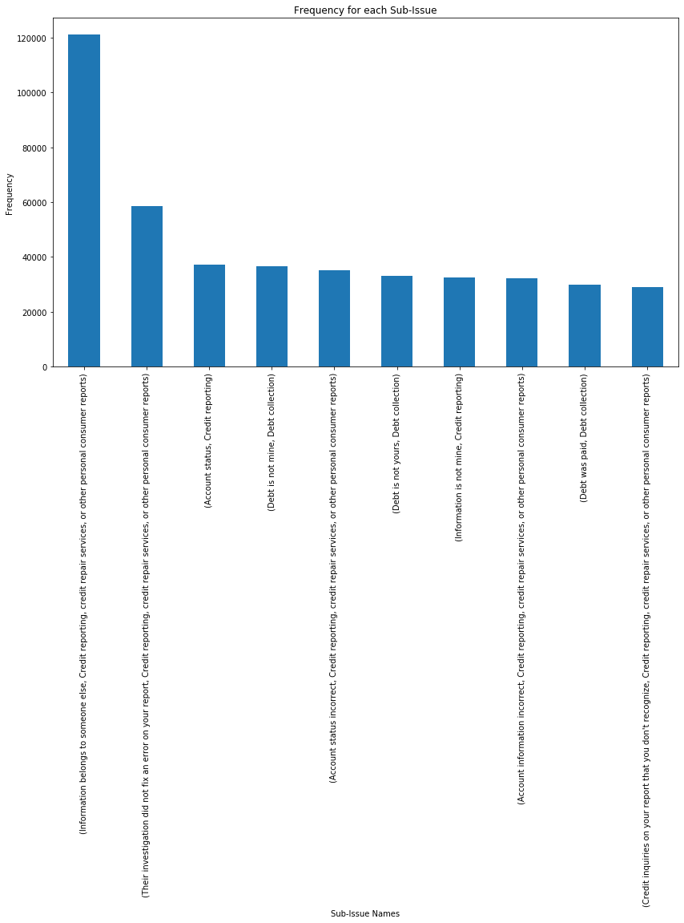

Sub-Issues:

1. Information on credit report belongs to someone else
2. Credit reporting company’s investigation did not fix the error
3. Account status (credit reporting)

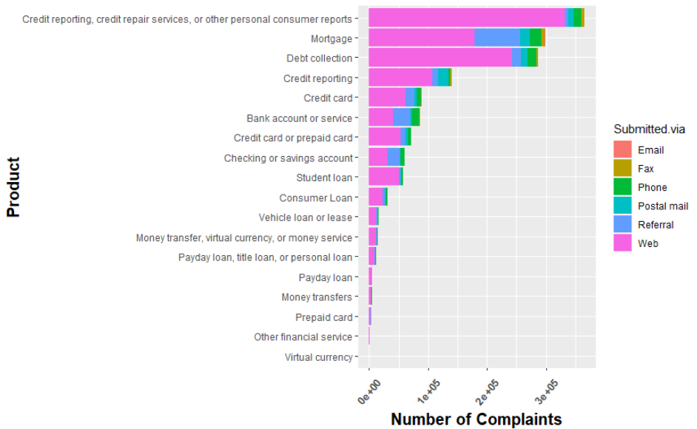

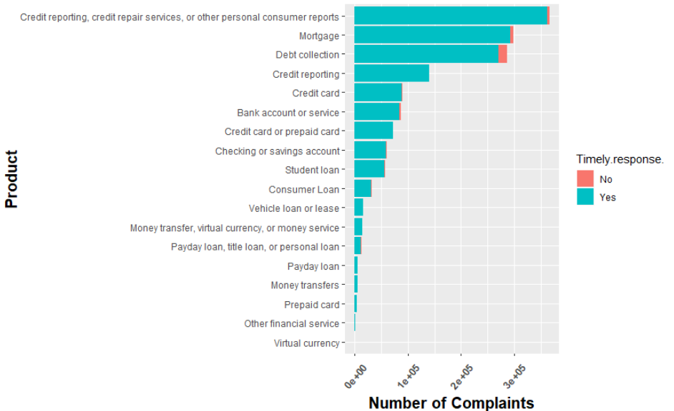

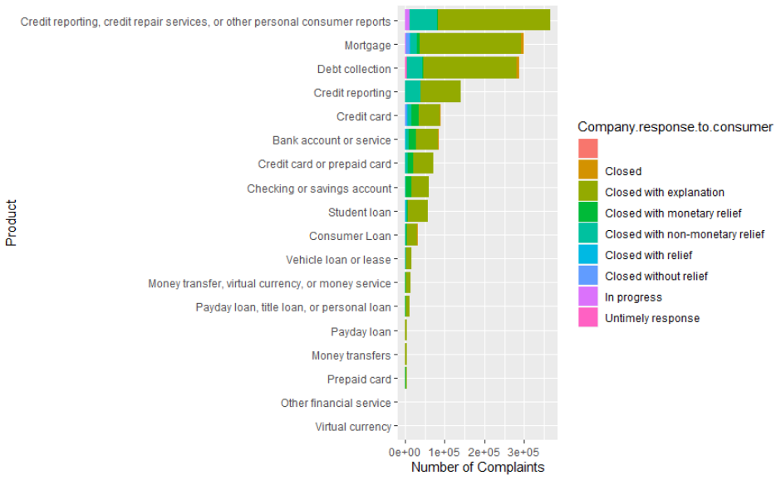

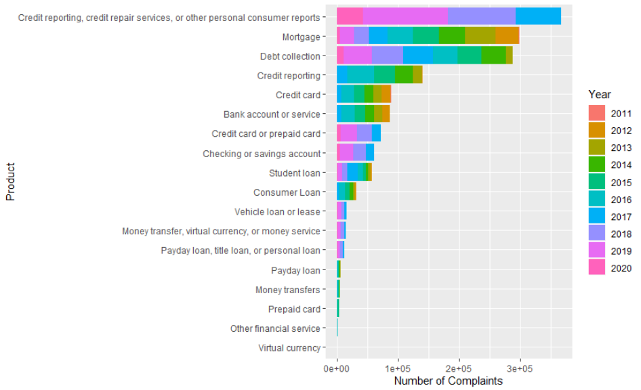

**Insight by Time**

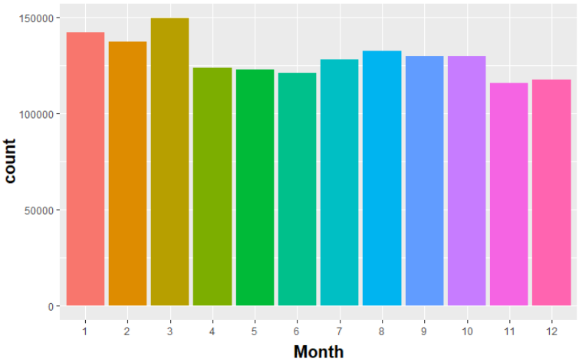

XX

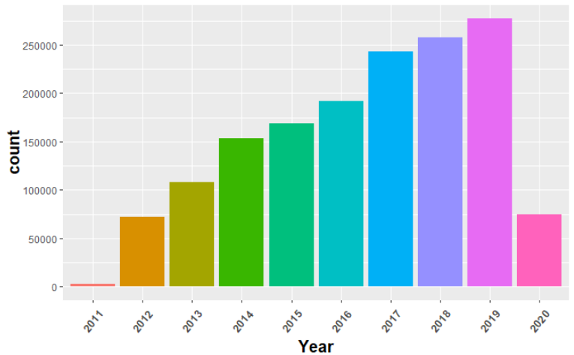

**Insight by Company**

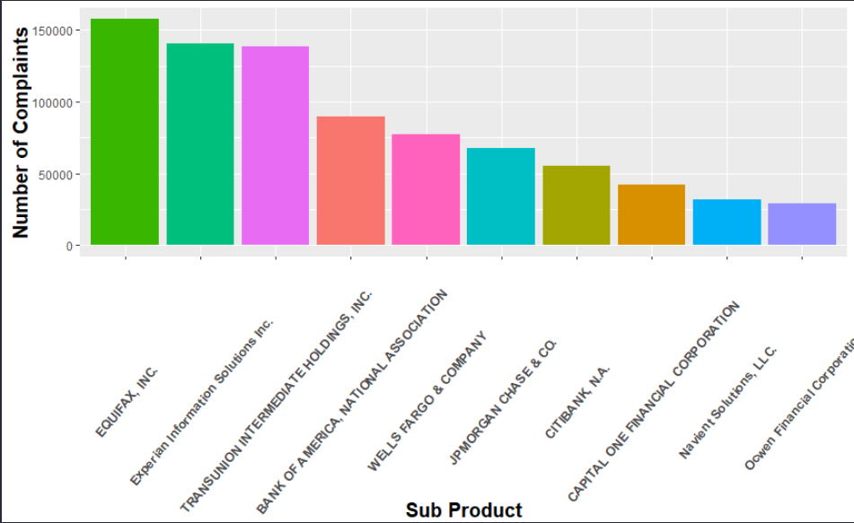

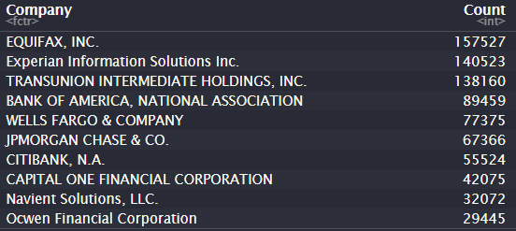

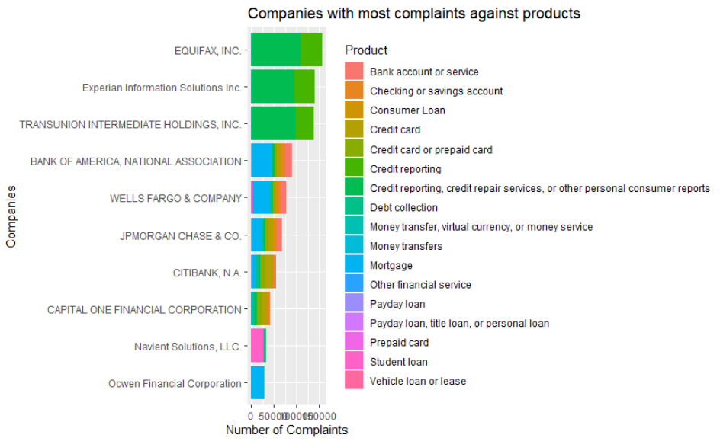

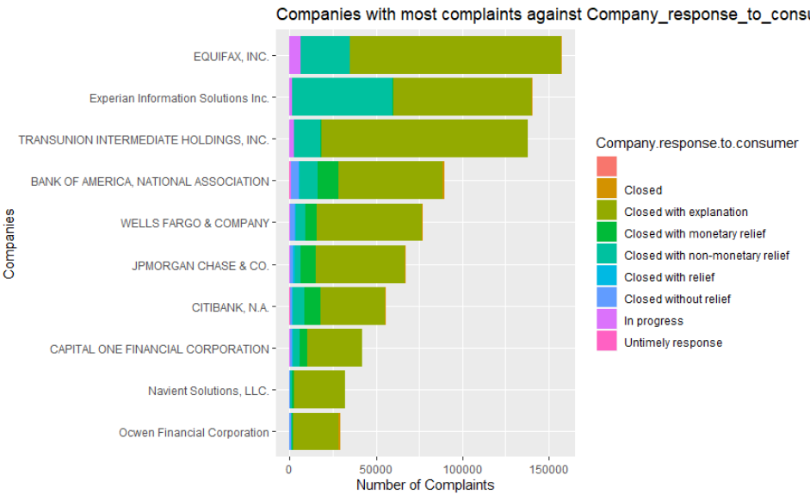

**Insight by State**

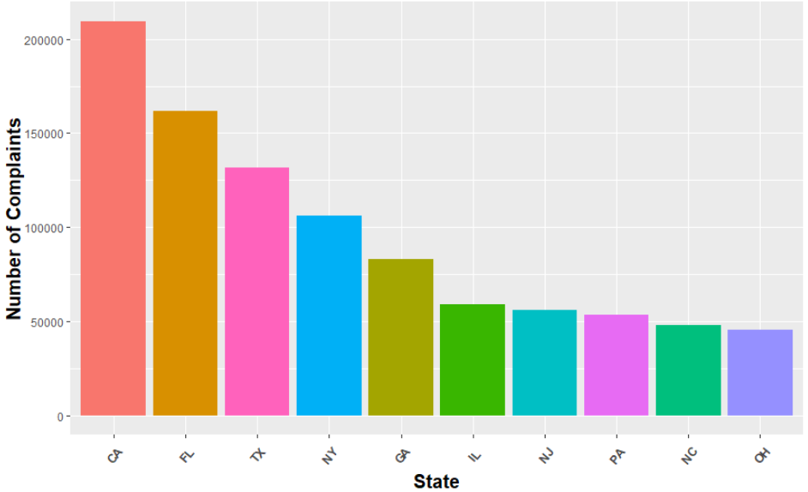

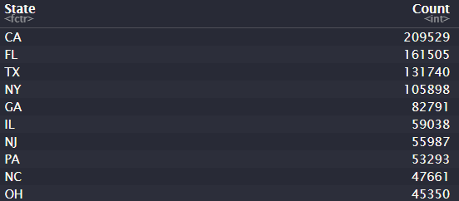

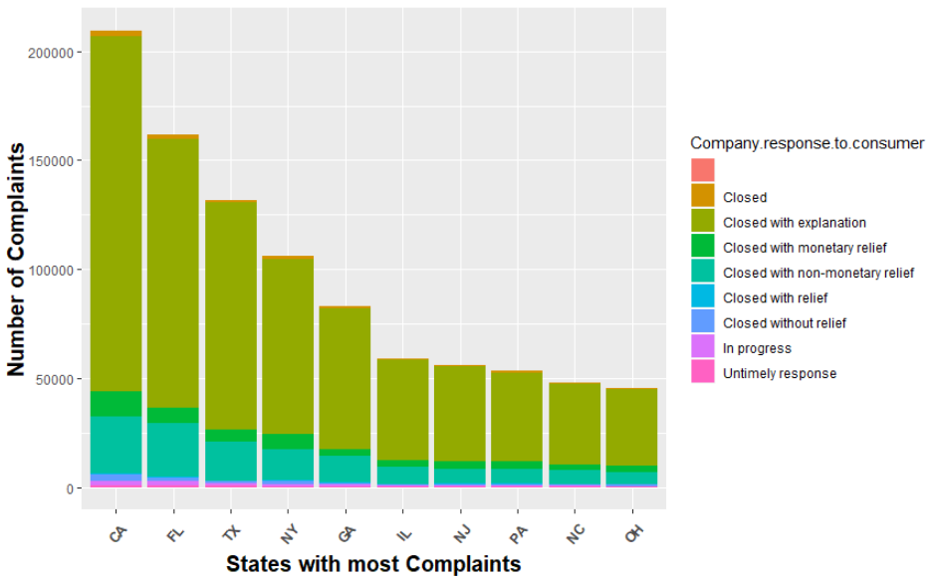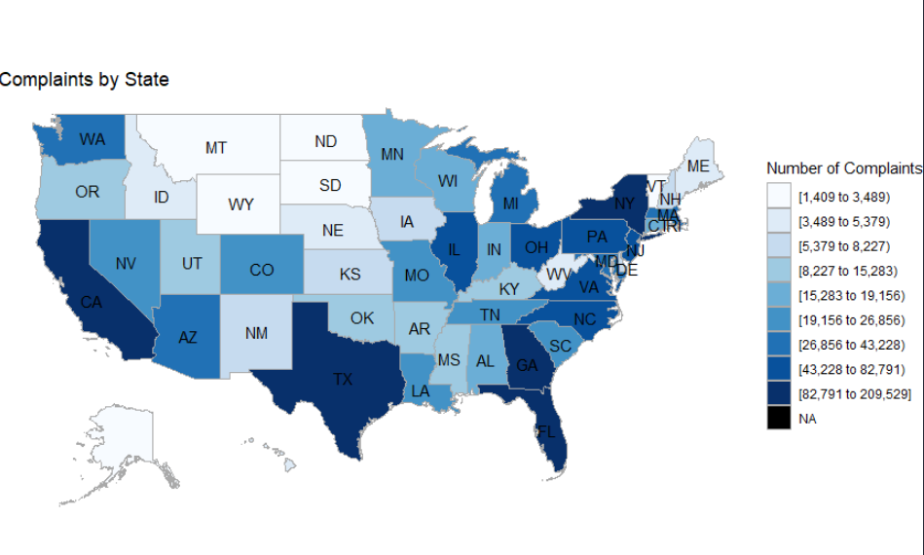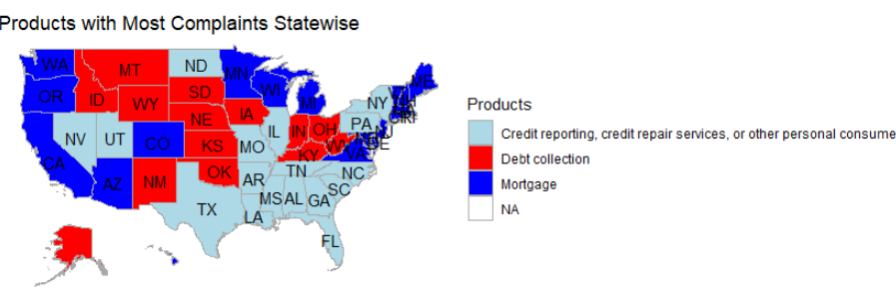

**Insight by Text**

*All Consumer Complaint Narratives*

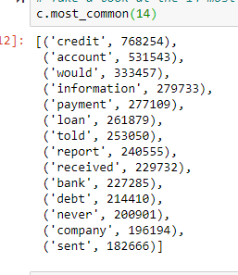 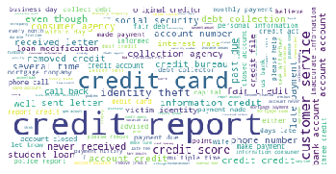

Top Issues:

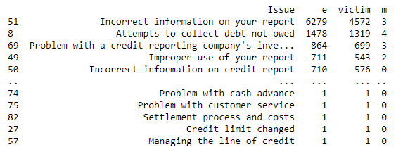

*Consumer Complaint Narratives When Product is Credit Reporting*

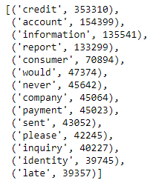 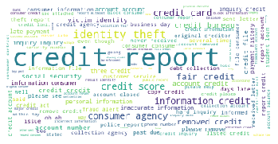

Top Issues:

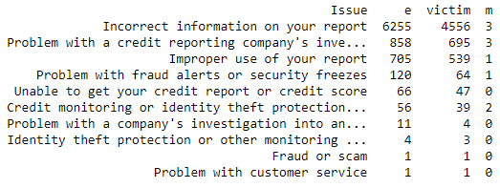

*Consumer Complaint Narratives When Product is Mortgage*

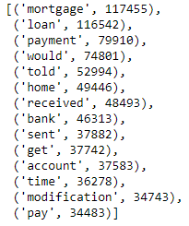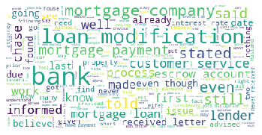

Top Issues:

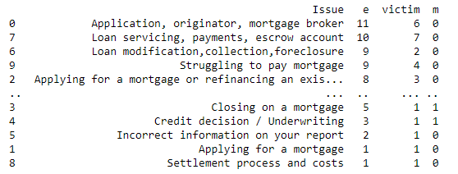

*Consumer Complaint Narratives When Product is Debt Collection*

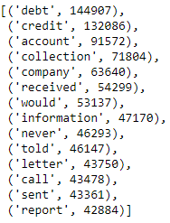 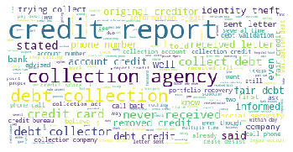

Top Issues:

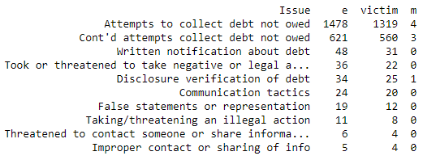

**Actionable Insights**

**By Problem Area**

The majority of issues are made up in the credit reporting realm. There are issues of what is on people’s reports and issues with fixing these problems. Identity fraud is a prevalent issue in the dataset, here are some testimonial examples:

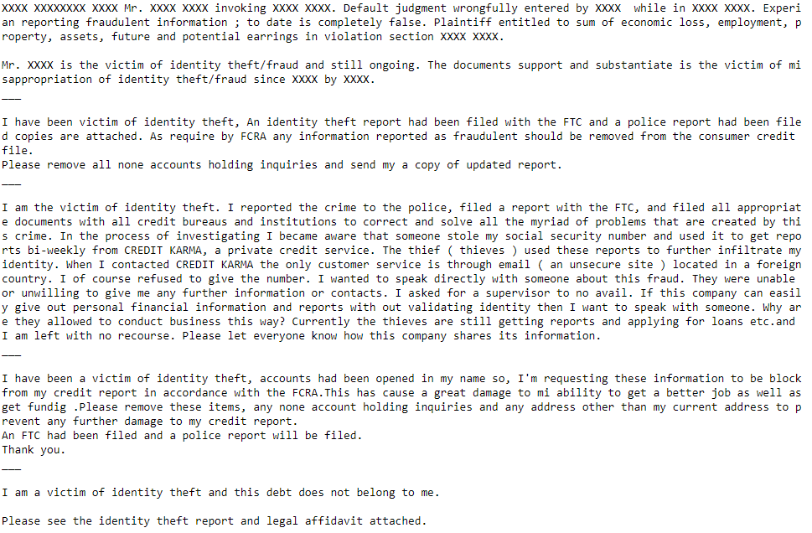

The second major issue is with mortgages.

The third major issue is with debt collection.

**By Time**

We can see a constant trend from 2012 to present of an increasing number of complaints. These complaints are becoming more and more credit related. Credit issues make up the bulk of complaints and they are only growing in the percentage of the total complaints that they take up.

At a monthly level, complaints are rather consistent. The highest reporting is done in the first three months of the year, perhaps because it is tax season and people are more tuned into their financial records.

**By Company**

The top three recipients of complaints are Equifax, Experian, and Transunion -- the big three companies that deal with credit reporting. This reinforces the idea that credit reporting is the major issue here.

The next top recipients are Bank of America, Wells Fargo, JP Morgan, and CitiBank. The bulk of these complaints deal with mortgages. This is where we get our second most important issue, i.e. mortgages.

**By State**

The top states that file complaints are CA, FL, TX, NY, and GA. California is the top contributor by a large number. These numbers are not too suprising as they are the most populated states. Four of the five most populated states take up this top 5.

We can gain some insight from the graph below and seeing what states deal with what issues. It looks like the southern states primarily deal with credit reporting. Debt collection takes up a lot of the midwest and mortgage complaints are fairly scattered.



**By Text**

Top issues when the product is credit reporting:



Top issues when the product is mortgage:



Top issues when the product is debt collection:



Cumulative Consumer Complaint Narrative Wordcloud:



Consumer Complaint Narrative Wordcloud for Credit Reporting:



Consumer Complaint Narrative Wordcloud for Mortgage:



Consumer Complaint Narrative Wordcloud for Debt Collection:

